Lab 3

Analog IC

|  |  |  |
| --- | --- | --- |
| Name | ID | Section |
| Nada Tarek Mowafi | 20012094 | 5 |
| Salma Hamdy Mohamed | 20010677 | 5 |

* **Inverting Schmitt trigger :**
* **The circuit:**

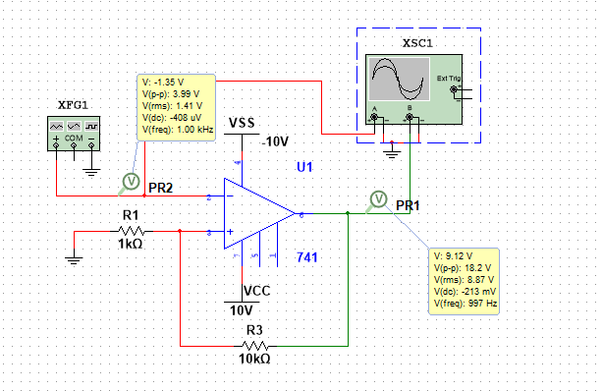

* **The output in the lab:**

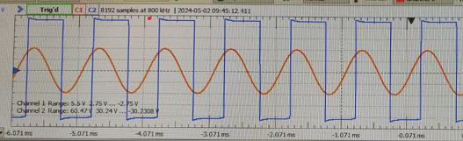

* **The output in multisim:**

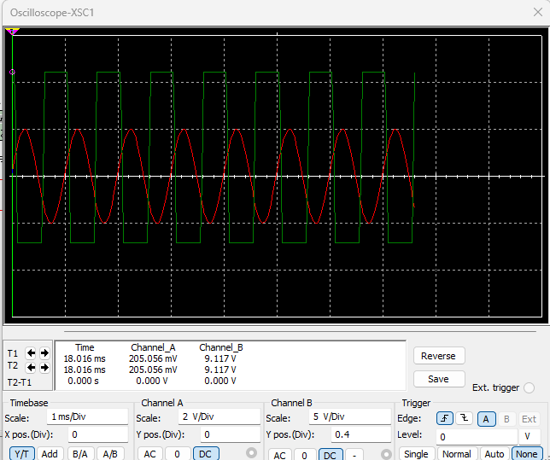

* The frequency response: 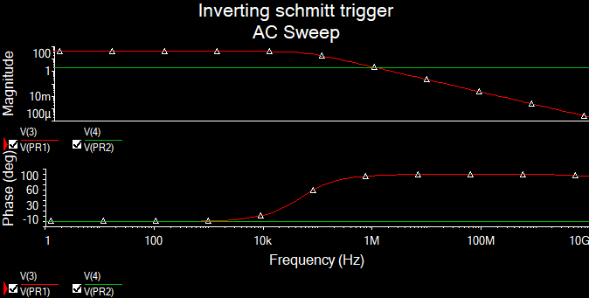
* The effect of changing R1 and R2:
* When lower R1:

The circuit:

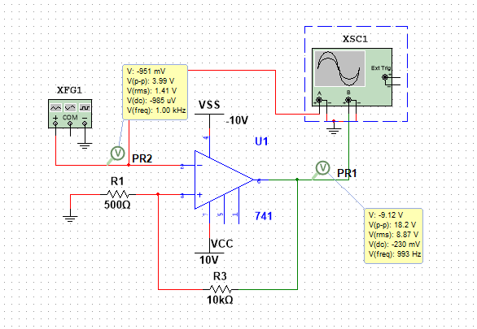

The output:

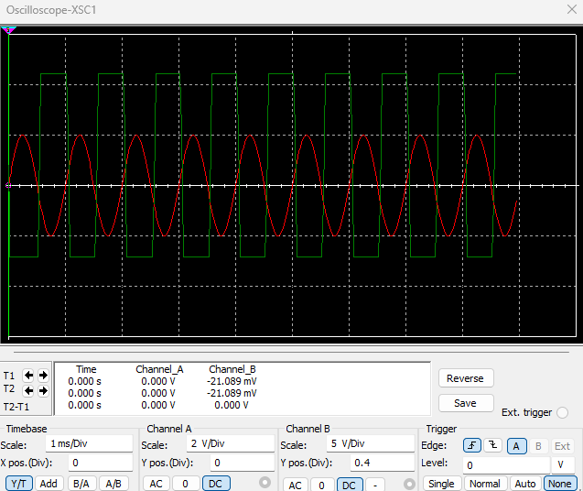

* When we increase R2:

The circuit:

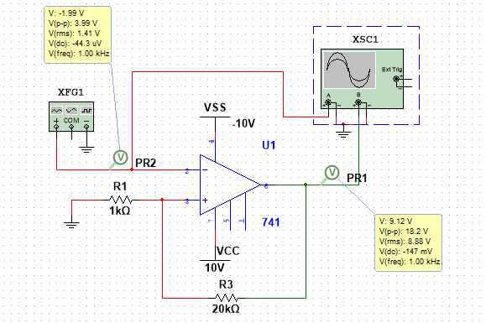

The output:

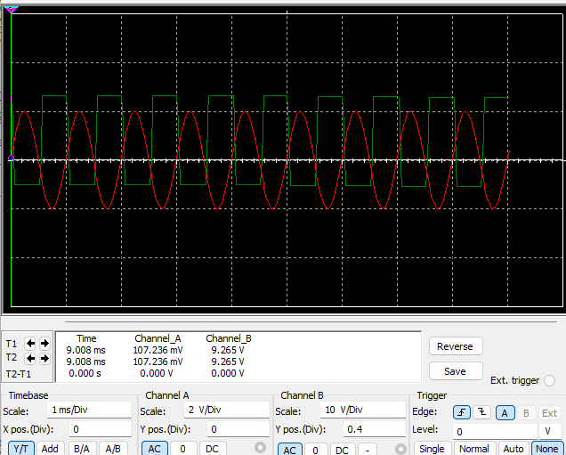

* Comment:

In an inverting Schmitt trigger circuit, the resistors R1 and R2 play a crucial role in determining the output behavior. Here's how varying their values affects the output.

* Lower R1:

Decreases the upper threshold voltage.

Increases the lower threshold voltage.

Net effect: Narrows the hysteresis loop. The output becomes more sensitive to smaller input signal changes.

* Higher R2:

Doesn't directly affect the threshold voltages (UT and LT).

However, it affects the overall gain of the inverting Schmitt trigger. A higher R2 increases the gain, amplifying the output voltage swing between positive and negative saturation levels.

* Non inverting Schmitt trigger:
* The circuit:

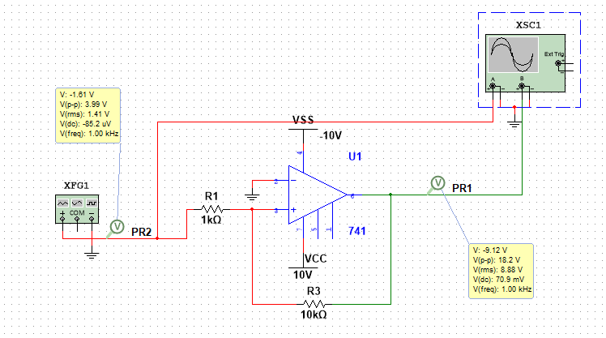

* The output in the lab:

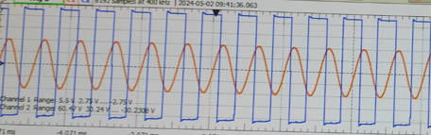

* The output in multisim:

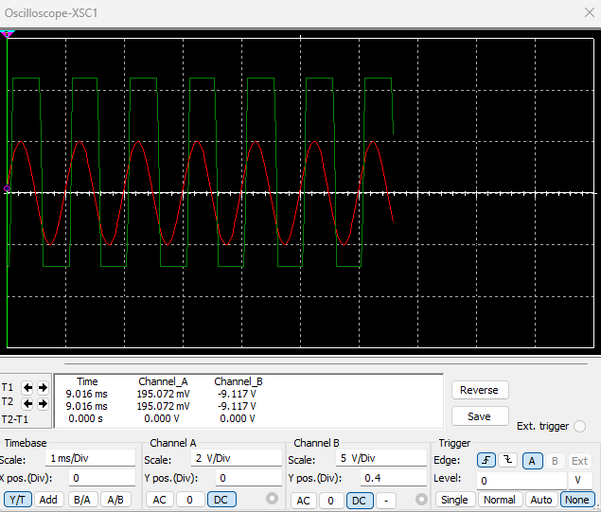

* The frequency response: 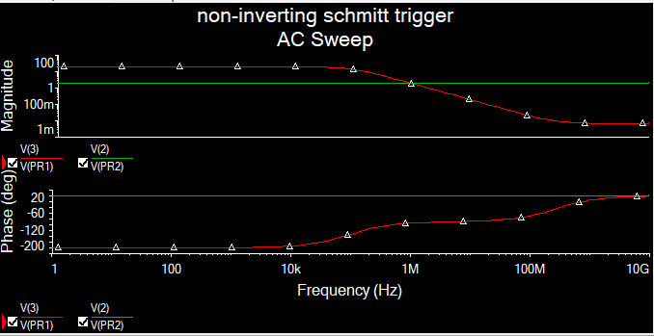
* Square wave generator:
* The circuit:

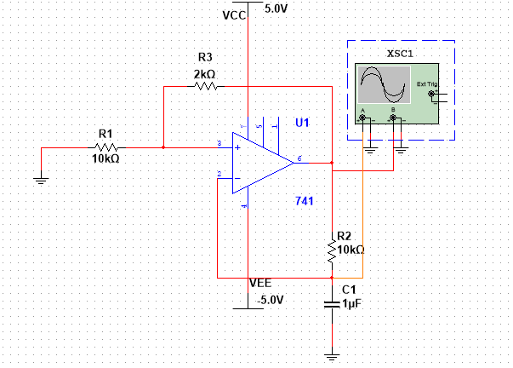

* The output from multisim:

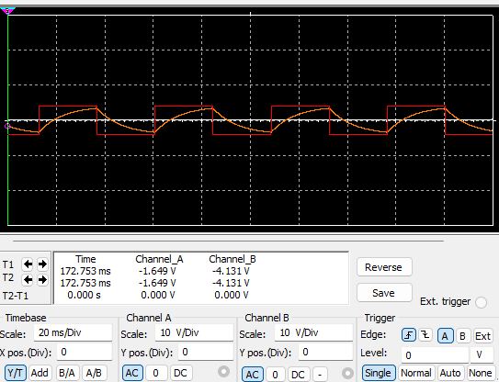

* The output in the lab:

